Sociology of the Social (common sense) | Sociology of Associations
Advances the existence of ‘society’, ‘social dimension’ | No ‘social dimension’
‘Social context’: separated domain of reality in which non-social activities take place | No ‘social context’, no distinct domain of reality to which the label ‘social’ or ‘society’ could be attributed
Social aggregate exists behind activites [law, science, …] | Nothing behind activities. Activities may be linked in a way that does or does not produce a society
‘Social’ if possesses specific properties | ‘social’ as a very peculiar movement of re-association and reassembling. Visible only by the traces it leaves when a new association is being produced between non-social elements
‘Social’ is glue that can fix everything | ‘Social’ is what is glued together by many other types of connectors
Separated domain can be used to  - Explain specifically social phenomena  - Explain ‘social aspects’ of other non-social domains | No ‘social force’ available to explain the residual features other domains cannot account for
Ordinary agents embedded in the social world (‘informants’). Fully visible only to social scientist | Actors know what they’re doing, more than ‘mere informants’ Task of defining and ordering the social world
Method: Settle controversies | Method: let actors deploy the full range of controversies in which they are immersed
Society made of social ties | Associations are made of non-social ties
Pre-relativist: fixed frame of reference | Fully relativist: ability to move between frames of reference
Social scientists impose some order & limits, teach actors what they are, add reflexivity to actors’ blind practice. | Social scientists ‘follow the actors’ & travel wherever new heterogeneous associations are made
Convenient shorthand of the social | Costly longhand of associations
Explanation begins with society | Explanation ends with society
Optimal for: most situations and situations evolving slowly | Optimal for: active, warm, extreme situations
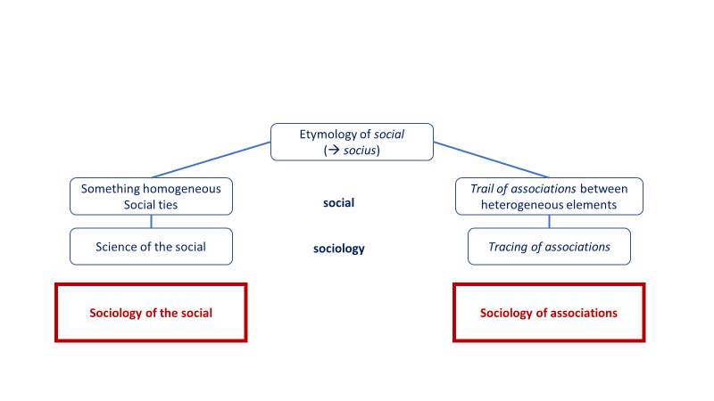
Sokal & Bricmont (Fashionable Nonsense):
Frame of reference
= Scheme for assigning spatial and temporal coordinates (x,y,z,t) to “events”
e.g. Event in NYC: 6th Avenue (x), 42nd Street (y), 30 meters above ground level (z), at noon on May 1, 1998 (t).

Misunderstandings:
- Thinks relativity is concerned with the relative location (rather than relative motion)
- Thinks 3rd reference frame is crucial. Also, stresses the need to discipline human observers
- Emphasizes alleged role of the ‘enunciator’ (reference frame with privileged role)

